**Lab 5**

**Name :-** Aryan Dilipbhai Langhanoja

**Date :-** 25-07-2023

**Enrollment No :-** 92200133030

**CO1: To write, test, and debug simple Python programs**

**CO2: To implement Python programs with conditional, loops and functions**

**Task 1:- List Inside Tuple and Tuple Inside List**

**Python Code:**

tuple1 = (2,'ABC',3+4j,[1,6.78,True],False)

tuple2 = (1,'def',[1,6.78,True],False)

print(tuple1 + tuple2)

print(tuple1[3] + tuple2[2])

list1 = [1,3.45,True,5+6j,1]

list1.remove(1)

list1.clear()

print(list1)

list2 = [1,2,3,'Aryan',True,3+5j,1,False]

print(list2.count(0))

list3 = [1,2,(1,2),(1,2)]

print(list3.count((1,2)))

list2.reverse()

print(list2)

list4 = [5,4,1,2,4]

list4.sort(reverse=True)

print(list4)

list4.sort()

print(list4)

**Output:**

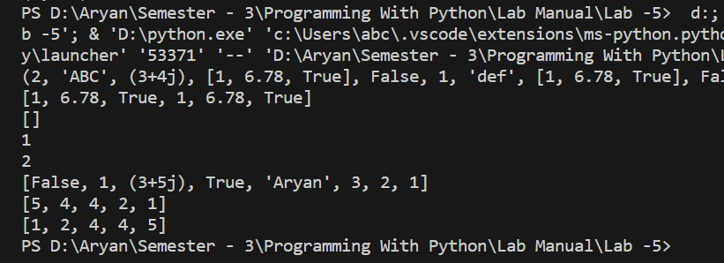

**Task 2:- Making Tuple of maximum and minimum of a Tuple**

**Python Code:**

tuple3 = (5,20,3,7,6,8)

list3 = list(tuple3)

list3.sort()

anslist = [list3[0] , list3[len(list3)-1]]

anstuple = tuple(anslist)

print(anstuple)

**Output:**

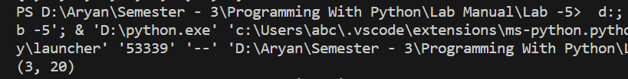

**Task 3:- Finding the Highest Frequency in theTuple**

**Python Code:**

inputtuple = (2,4,5,6,2,3,4,4,7)

inputlist = list(inputtuple)

inputlist.sort()

freqlist = [inputlist.count(inputlist[0]),inputlist.count(inputlist[1]),inputlist.count(inputlist[2]),inputlist.count(inputlist[3]),inputlist.count(inputlist[4]),inputlist.count(inputlist[5]),inputlist.count(inputlist[6]),inputlist.count(inputlist[7]),inputlist.count(inputlist[8])]

freqlist.sort()

print(freqlist[len(freqlist) - 1])

**Output:**

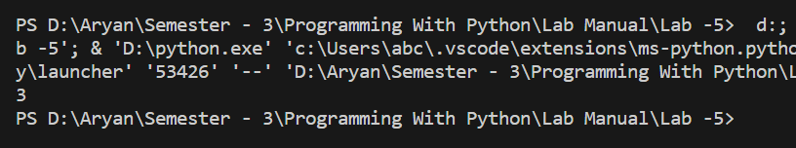

**Task 4:- Demonstrate The Usage Of Dictionary**

**Python Code:**

D1 = {'Mango' : 150 , 'Grapes' : 250}

print(D1)

print(D1.get('Mango'))

print(D1.keys())

print(D1.values())

print(D1.items())

**Output:**

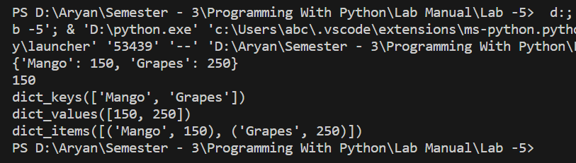

**Task 5:- Demonstrate The Usage Of Sets**

**Python Code:**

set1 = {1,7,8,9,7,6,5,3,4,1,1,9,7,6}

set1.add(0)

print(set1)

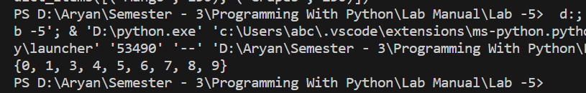**Output:**

**Task 6:- Joining The Characters Of Tuples**

**Python Code:**

tup2 = ("I" , "C", "T")

print(''.join(tup2))

**Output:-**

